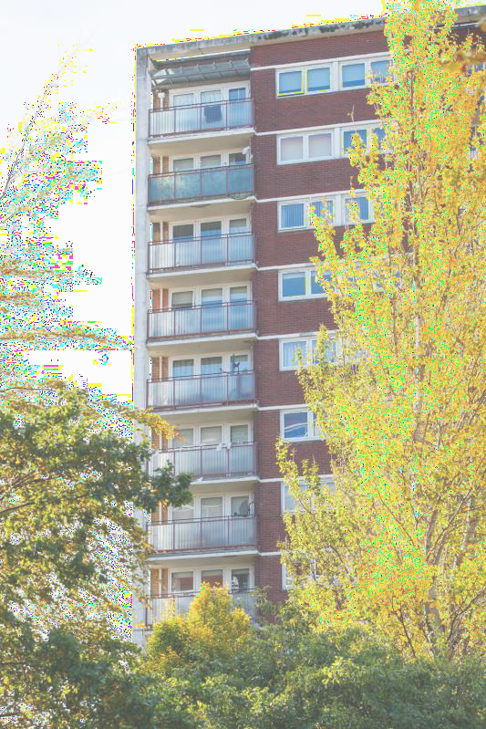
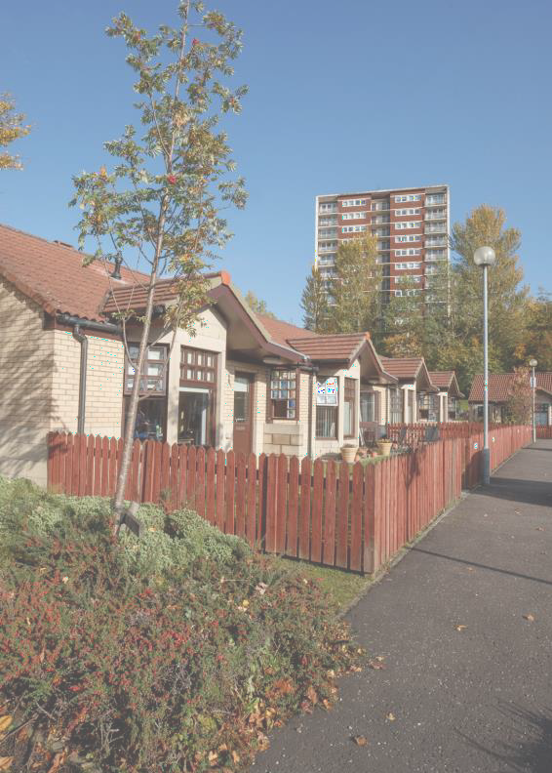
Linthouse Housing Association
1 Cressy Street Linthouse Glasgow G51 4RB

Application for Housing Guide: Summary of the point system

[Moutgarrie Road multi storey amenity flats]

If you would like to apply for housing with Linthouse Housing Association please contact our Customer Service Team for advice.
We can provide you with more advice about:

- The types of houses we have for rent

- The areas where our houses are situated

- Your chances of being re-housed
Linthouse Housing Assoc
1 Cressy Street Glasgow
G51 4RB

We can also provide support and assistance to complete the housing application form.
Remember!

You need to provide proof of
ID/ residency to allow us to assess your application.

The kind of things we can accept are:
●a letter/statement/ bill from your Local Authority or Council (e.g., Council Tax); ● a letter/statement/ bill from your gas or electric company; ● your payslip with address; ● a DWP letter; ● a Housing Benefit or Universal Credit letter; ● a
letter from your landlord; ● your tenancy agreement or private sector lease; ● a bank or building society letter or
statement; ● a current photographic
driving license with your address on it; ●
or a national health card.

About Us

Linthouse Housing Association (LHA) is a community- based 'not for profit’ housing association and is a recognised Scottish Charity (registration number SC028161).

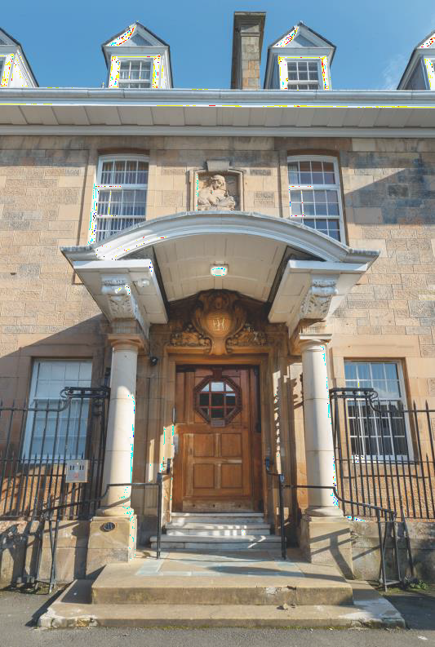

[1 Drumoyne Drive amenity flats)

We allocate our houses based on the number of points you are awarded. The following is a summary of the points system that we operate:
Homeless or Threatened with Homelessness: 20 points

Insecure tenancy points: someone renting private rented tenant and has been given notice to leave: 10 points

Property is Below Tolerable Standard: 20 points Property has Penetrating Dampness: 10 points Property has Serious Condensation or Mould Growth: 10 points
Overcrowding: for every bedroom lacking against our occupancy standards (see table below): 10 points

Apartment Size: | 1 | 2 | 3 | 4 | 5
& Household Type (below):
Single Person | √ | √ | √
Couple |  | √ | √
Couple/Single Parent  with 1 Child |  |  | √
Couple/Single Parent with 2 Same Gender Children Under 16  years |  |  | √
Couple/Single Parent with 2 Children of Opposite Genders  Under 10 years |  |  | √
Couple/Single Parent with 2 Children of Opposite Genders and One Over 10  years |  |  |  | √
Couple/Single Parent with 3 Children, One Male Over 10, One Female 17 and One  Female 14 |  |  |  |  | √
Couple/Single Parent with 4 Children, 1 Male Over 10, One Female over 16, One Female 8 and One  Male 6 |  |  |  |  | √

Lacking amenities: lacking suitable kitchen/ cooking facilities; inside toilet; bath or shower; hot water supply: 6 points

Sharing amenities: applicants who have access to kitchen/cooking facilities, toilet, bath, shower or living area, but share more than 2 of these facilities with family or friends or as a lodger: 8 points

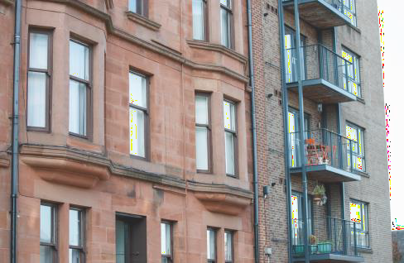

[Aboukir Street, Linthouse]

Mobility/Medical Condition

- High Priority: 30 points
- Medium Priority: 15 points
- Lower Priority: 5 points (LHA tenants only)

Social/Family Need

- someone is seeking to move into the area to receive or provide support to a family member: 20 points
- someone has been approved for adoption or kinship and has other unmet housing needs: 15 points
- employed locally and the applicant lives out-with the Glasgow City boundary: 5 points

Harassment or abuse

- High Priority: 30 points
- Less Serious Priority (LHA tenants only): 16 points

Social housing tenants who are under-occupying their home:

- first bedroom: 15 Points
- every additional bedroom extra: 10 points

