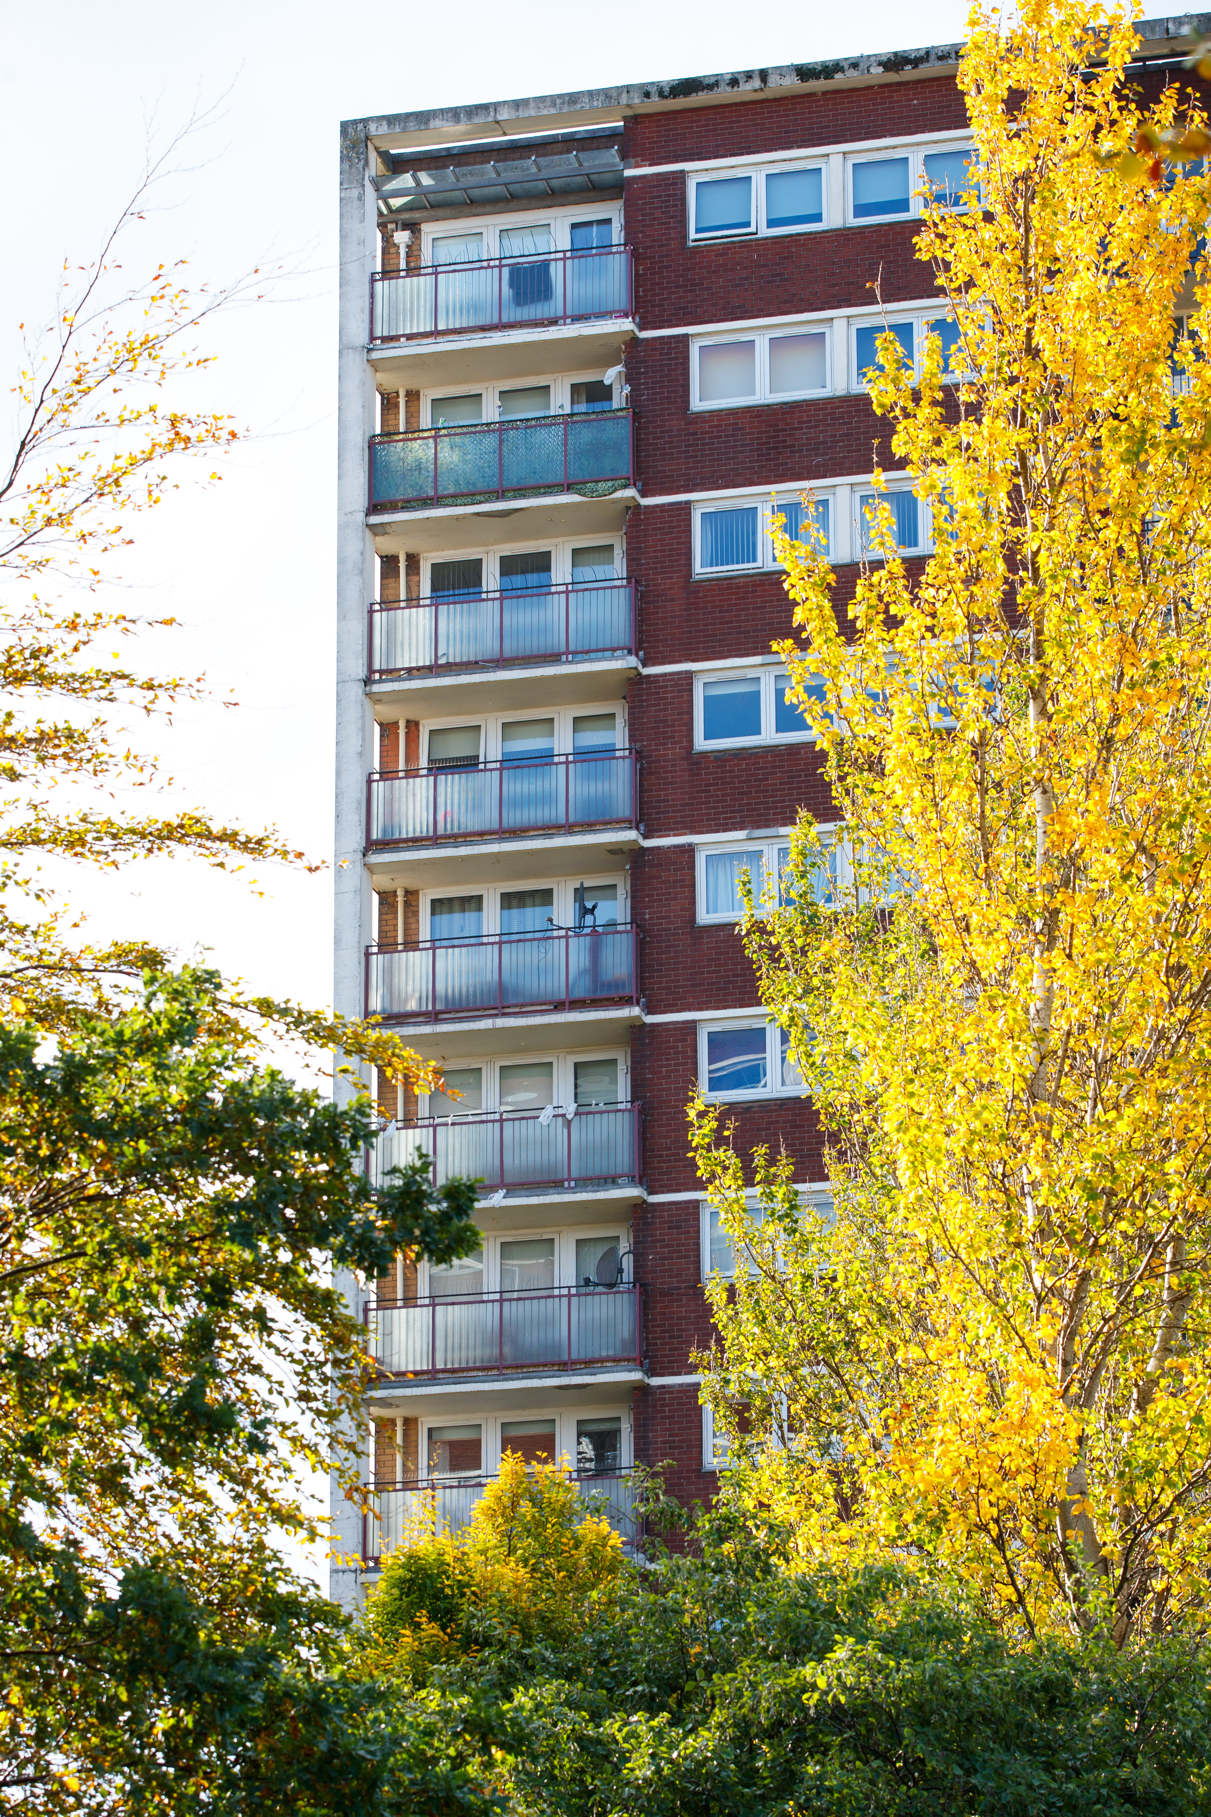  [Moutgarrie Road multi storey amenity flats]  If you would like to apply for housing with Linthouse Housing Association please contact our Customer Service Team for advice.  We can provide you with more advice about:  - The types of houses we have for rent  - The areas where our houses are situated  - Your chances of being re-housed  We can also provide support and assistance to complete the housing application form. |  |  | Who We Are  About Us  Linthouse Housing Association (LHA) is a community-based 'not for profit’ housing association and is a recognised Scottish Charity (registration number SC028161).  Contact Us  Phone: 0141-445-4418  Email: enquiries@linthouseha.com  Web: www.linthouseha.com  Linthouse Housing Association  1 Cressy Street Glasgow  G51 4RB |  |  | - Linthouse Housing Association  - 1 Cressy Street Linthouse Glasgow G51 4RB  Application for Housing Guide: The areas and types of houses we manage
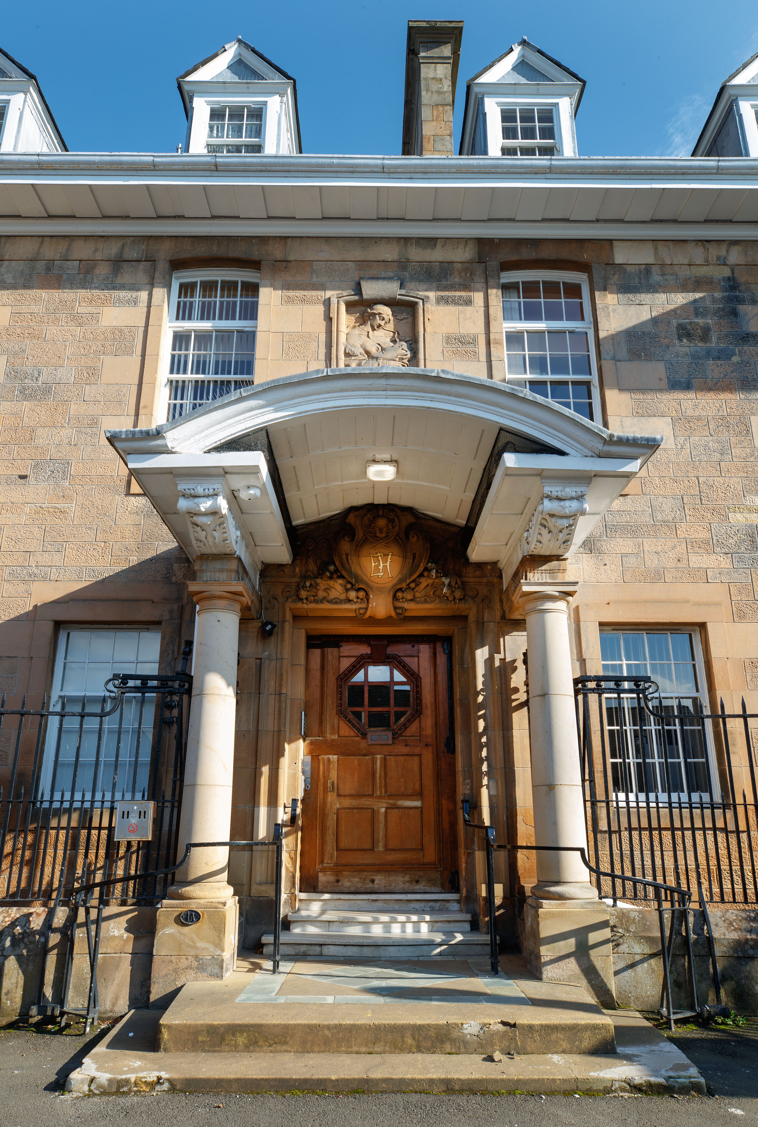  [1 Drumoyne Drive amenity flats)  We have houses for rent in the Linthouse, Langlands & Drumoyne area of Govan in Glasgow.  The individual streets are listed:  Streets in the Linthouse Area:  Aboukir Street (pre-1919 tenements & tenements)  Barnwell Terrace (pre-1919 4 in a block)  Burghead Drive (pre-1919 tenements) Burghead Place (pre-1919 tenements)  Clachan Drive (pre-1919 tenements)  Cressy Street (pre-1919 tenements) |  |  | Drive Road (pre-1919 tenements)  1 Drumoyne Drive (Elder House - Amenity Flats & Cottages)  Govan Road (pre-1919 tenements & tenements)  Holmfauld Road (pre-1919 tenements & tenements)  Holmfauldhead Place (pre-1919 tenements)  Hutton Drive (pre-1919 tenements)  Kennedar Drive (pre-1919 tenements)  Linthouse Buildings (pre-1919 tenements & main door)  Luma Gardens/ Hardgate Road (4 in a block)  Moss Road (pre-1919 tenements)  Peninver Drive (pre-1919 tenements)  Skipness Drive (pre-1919 tenements)  St Kenneth Drive (pre-1919 tenements)  Streets in the Langlands Area:  Mallaig Place (main doors)  Mallaig Road (multi storey - all amenity)  Mallaig Road (tenements & main doors)  Marchglen Place (main doors)  Meldon Place (main doors)  Melness Place (main doors)  Melvick Place (main doors)  Morefield Road (tenements)  Mountgarrie Path (tenements)  Mountgarrie Road (multi storey - all amenity)  Munlochy Road (main doors)  Murroes Road (tenements & main doors)  Mybster Place (main doors)  Streets in the Drumoyne Area:  Balbeg Street (tenements)  Elder Grove Court (amenity main doors)  Finsbay Street (main doors)  Meiklewood Road (tenements)  Shieldhall Road (tenements) |  |  | 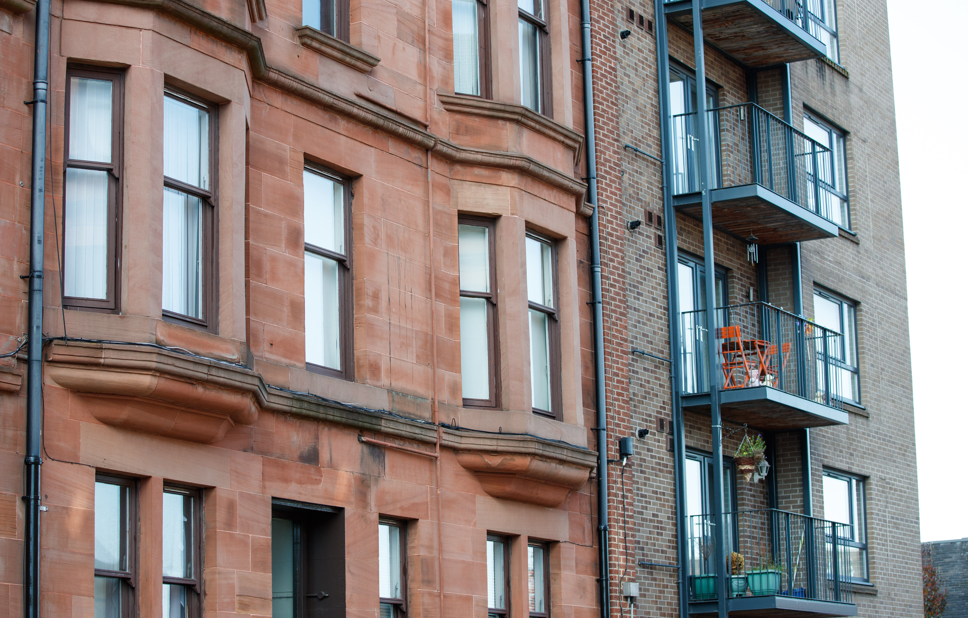  [Aboukir Street, Linthouse]  The types of house we have for rent are described below:  Pre-1919 tenements: traditional sandstone tenement flats, typical of the style of flats available in Glasgow.  Amenity Housing: accommodation for people who are over 55 only (unless there is a medical issue that this type of housing would support). We currently have amenity housing in our multi-story flats, our grade A listed Elder House at 1 Drumoyne Drive; and our newly converted main door properties at Elder Grove Court in Drumoyne).  Main Door: Main door and back and front door properties, mainly in the Drumoyne and Langlands area.  4 in a block: We have a small number of 4 in a block flats.  Tenements: we also have a number of flats which are off a main close and classified as tenements.

